Consumers’ Perception of Prices on English Food Menu

¹Haya Haratikka*, ²Rapat Piter Sony

^{1,2,} Sekolah Tinggi Ilmu Ekonomi Bina Karya

¹hayaharatikka@gmail.com, ²piter.pospos@gmail.com

Abstract
Nowadays, the use of the English has become popular. It spreads to all life aspects, especially in the cafe/restaurant business. The cafe/restaurant owners used English as written on the menu list. This was experimental research; with 25 respondents as the control group and 25 as the experience group. This research was going to investigate whether the use of the English in the food and drink menu significantly affects business profit. The data of this research were taken from 25 of STIE Bina Karya’s students who ordered from the cafe/restaurant whose menu were written in English. Then, the data were analyzed quantitatively from the result of the goggle-survey distribution. As a result, the price indicators, showed that consumers did not mind the higher prices at restaurants/cafes with English language menus offered. Therefore, the business people were suggested to use English language as written on their menu list.

Keywords: price, English language, restaurant and cafe

INTRODUCTION

Indonesia is categorized as a developing country in Asia with the 4th most populous country. The large population makes Indonesian citizens have to compete to get jobs. The more population the more subject to development, the more economy will develop if the number of workers is a lot too. Therefore, this situation will raise economic growth. Hence, the Indonesian governments need to equip human resource by improving the quality and ability of the workforce (Rochaida, 2016). There are several ways to improve the quality of prospective workers, one of them is by giving international language training. Through international language training, prospective workers will be able to compete in this actual globalization era (Aziz, 2014).
Our daily activity is inseparable from the use of language. Human language is used to convey ideas, thoughts, and information which are essential in human life (Hija, 2020). A Language is a communication tool that is organized in form of some units, like word, group of words, clause, and sentences which is delivered spoken and written (Wiratno & Santosa, 2014) which are different. Spoken language occurs spontaneously, like a conversation which presumably gets some evaluation from the audience, while written language is planned (Cao Thanh, 2015). The use of language should be understandable for both speaker and listener for spoken language as for author and reader for written language.
Language is dynamic, and evolves with the times. Nowadays, the use of a foreign language, especially English language, is a must in all life aspects. This symptom is called xenoglosofilia, the tendency to use foreign languages rather than local/national one. In this globalization era, the use of the English in daily life cannot be avoided including in the bussiness sector (Khasanah et al., 2015). For example, the use of the English language in the business sector, such as the restaurant’s or cafe’s name and the menu on the lists, are using the English language. This is called as the business language. Business language is used by a member of a group of people in the trade, business, and entrepreneurship the use of English language for business actors has a positive meaning for their business, including for those who are running restaurant and cafe business. They apply English to label their restaurant’ name and to write the menu in English.
There are several reasons why business people apply the English language in their business, those are to get the prestige, seems seem to be cool calm to be attractive, to look charming, to look more professional, to keep the business continue, to be more classy, to be more intellectual, to improve the quality, not to look old-fashioned, to be trendy, and to be more fashionable (Haryanti et al., 2019).
Along with the preliminary data, the researcher found that a menu in a cafe in Tebing Tinggi that was written in the English. However, the meals and the drinks are in Indonesia’s taste and style. It was not international taste at all. Then, observing the price on the menu list, the researcher found that the price tag was higher than usual compared with the cafe whose menu list was written in Indonesian language. For example, cafe A has telur dadar in Bahasa Indonesia tagged Rp. 10.000,- whether in cafe B it is written ómelette (English language) was Rp. 33.000,-. The prices between these two cafes are quite different, cafe B has higher prices than cafe A. However, the product (food) has the same primary material. Moreover the fact was that customers kept purchasing the same food (product) in that cafe. After seeing this phenomenon, the researcher wanted to see customer’s opinions about the price on the menu as written in the English.
In this research, the researcher gave a different treatment to two different groups of the respondents. Treatment was given to the 25 consumers through the menu list as written in English language and a treatment to 25 customers who have the menu in Indonesian language. The group with the menu list written in the English is the experiment group, and the group with the menu list written in Bahasa Indonesia is the control group.
After analyzing the data, the researcher wanted to find out the customer percentage who ordered the menu in English or Indonesian language from the same menu. Then, ask customers’ opinions about the price of the menu in the English version. The problem of this study was “Did the price written in English menu give a significant effect on the cafe/restaurant?
The objective of this research was to prove whether the use of the English in a restaurant/cafe’s menu would significnaltly impact the business profit.
LITERATURE REVIEW

Price
Price is the only element in marketing mix makes a profit for the company. Therefore, the company needs to set fixed price for the product. The set price level affects the number of products which is sold. In addition, prices also affect costs indirectly, because the quantity sold affects the costs incurred concerning to production efficiency. Hence, pricing affects total revenue and cost, then decisions and strategies for pricing plays an important a vital role in every company (Shabastian & Samuel, 2013) .
Price has two leading roles in the decision-making process for consumers, namely the role of allocation and the role of information. The allocation role of price is a function of price in helping buyers decide how to obtain the highest expected benefit or utility based on buying ability. Thus, a price can help the buyers decide how to allocate their buying ability to the various types of goods and services. Buyers compare prices from various available alternatives, then decide on the desired allocation of funds. The informational role of price is a function of price in “educating” consumers regarding product factors, such as quality. This is especially useful when the buyer has difficulty assessing product factors or objective benefits. The perception that often prevails is that the expensive price reflect high quality (Mulyana, 2019).
According to Kotler and Amstrong, as cited by Wibowo & Karimah (2012), price is the amount of money that consumers pay the producer to gain the product or service they want to purchase (a value of a product/service). Prices are usually set by the seller or the service owner. In addition, price becomes the primary factor that influences people before deciding to purchase. therefore before, setting a price for a product, and the company should consider some price list references of a product that rated relatively high in the sale. There are four price indicators: 1) affordability, 2) Price match with product quality, 3) Price competitiveness, 4) Price match with benefits,

English Language for Business
The use of the English language for business especially, in industrial sectors, is an opportunity to run their business, for example, in the hotel, spa, culinary, gift center, and so on. Language diversity triggers language users, such as national and traditional languages, to do code mixing and code switching in the language of advertising, da'wah, and campaigns. Business language is the language used by members of a society in the world of commerce, business, and trade. Language is used not only to communicate, but also to promote a place or a product. The indicator of a language is a business language which is divided into two things, namely (1) business language overrides the provisions of the Indonesian language at the syntactic level and (2) business language is used for business, promotion, or tourism purposes. Two factors influence the language attitude tendency. The two factors are internal factors and external factors. Internal factors come from entrepreneurs’ aspiration and prestige, including the identity of entrepreneurs and prestige. External factors relate to the need for naming projects or buildings by adjusting the location. These two factors are seen as symptoms of using foreign languages among entrepreneurs. They used the English language in their business to attract customers because it considered being able to give a positive meaning to their business. The nuances of positive meaning vary in form, for example, to increase prestige, be cool, attractive, add charm, be professional, launch business, be classier, more intellectual, improve quality, not old-fashioned, trendy, more fashionable, and so on (Suryawati & Osin, 2019) (Gasimova & Huseynova, 2018).

Restaurant and Cafe
Cafes and restaurants were where the customers could find the English Menu for this research purpose. According to Puspoyo et al. restaurant is a commercial enterprise that provides food and beverage services professionally managed one of its characteristics is that food and drinks’ price are relatively high. A Café is a suiDiagram place for relaxing, unwinding, and meeting with relatives. In general, a cafe provides food and drink that resembles a restaurant in a visitor service system, which can be used as a place to relax and chat while being entertained by music. Cafes tend to prioritize entertainment served with the convenience of customers in enjoy the dishes, as well as the taste and variety of the menu take precedence (Puspoyo, Aditya Chandra Setiawan, Andereas Pandu Wondo, 2015) which the age range are among 15 to 50 years old.

METHOD

This research applied quantitative research with experiment method, which implements the primary data. The data were gained through an online questionnaire. The researcher distributed the link to the respondent. Then, the data were analyzed by using Likert Scale Statistically.,The researcher did library research and some supporting documents to support the data. This research’s respondents were 50 students of STIE Bina Karya in Tutorial class divided into 2 groups, an experiment group, and a control group; both already have worked and have a monthly salary.
The researcher distributed the google – survey questionnaire to gain the respondent data. Before they filled out the questionnaire, the respondents got an example of the menu in the English language. The obtained data was analyzed using descriptive statistics. Then, the results are displayed in percentages. The data were grouped using the Likert Scale: 5 (strongly agree), 4 (agree), 3 (neutral), 2 (disagree), and 1 (strongly disagree).

FINDINGS AND DISCUSSIONS

This study aims to see respondents’ perception of the prices on the menu as written in the English language. This research examined four price indicators as consumers’ considerations before purchasing a product. Those are 1) affordability, 2) Price suitability with the product quality, 3) price competitiveness, and 4) price suitability with the benefit.

Diagram 1. Customers’ ability to afford the prices on the English menu
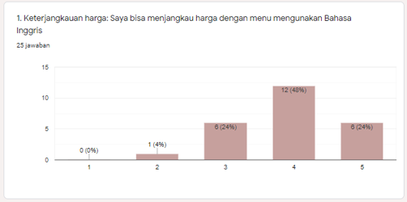
Diagram 1 shows that customers can mostly afford the menu written in English by sacrificing more money. Even though the prices on the English menu are more expensive than the menu in Bahasa Indonesia, the fact was twenty four respondents could afford the menu and its cost. Only one respondent was not able to afford the cost of the English menu. This result is supported by previous rezsearch, which reveals that producers need to do a pricing strategy to raise the company’s profit (Xia et al., 2021).

Diagram 2. Customers’ opinion on the price labeled in English menu is suiDiagram with the food/drink quality
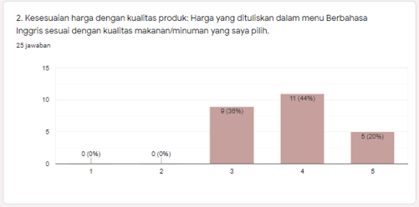
Diagram 2 indicates that written in English are suiDiagram for the foods/drinks quality. Mostly, customers agree with the prices as written in the English menu.
They got the quality of foods and drinks they ordered. As seen in Diagram 2, all respondents (25 respondents) did not mind the number of the cost they should pay for.
Diagram 3. Customers’ opinion of the English menu price’s competitiveness
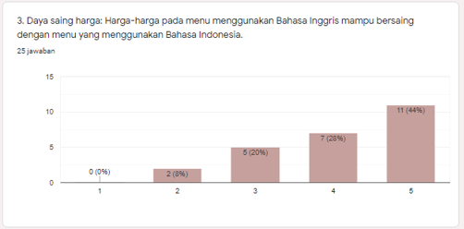
Diagram 3 shows that customers agreed that the prices on the English menu compete with the menu written in Bahasa Indonesia. Twenty three of twenty five respondents agree with the prices and its competitiveness among other menus in other restaurants/cafes. Two of them did not agree with the English menu price’s competitiveness.

Diagram 4. English menu’s price is suiDiagram with the benefits
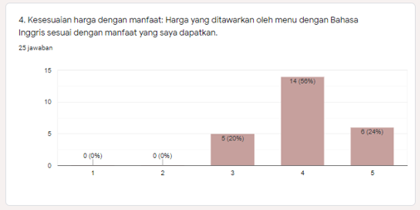
Diagram 4 indicates that even though customers sacrifice more money, it is appropriate as long as they are satisfied with the benefit they get. All the respondents agreed if they got the benefit with the amount of money they should pay. This is in line with the previous research said that consumers will make spontaneous decisions when an individual has knowledge price and a “health” motivation (van der Molen et al., 2021).

CONCLUSION

This research observed the significant use of the English language in the cafe/restaurant menus. Based on the price indicators, those are 1) affordability, 2) Price suitability with the product quality, 3) price competitiveness, and 4) price suitability with the benefit. It found that the consumers did not mind to paying more money as they ordered food/drink from the English menu list as long as they got satisfaction. The findings revealed that producers (cafe/restaurant) should consider their services, and offence in order to attract to consumers and get the business profit.

REFERENCES

Aziz, A. L. (2014). Penguatan identitas bahasa Indonesia sebagai lambang identitas nasional dan bahasa persatuan jelang penerapan Masyarakat Ekonomi ASEAN ( MEA ) 2015. Studi Sosial, 6(1), 14–20. http://lp2m.um.ac.id/wp-content/uploads/2014/03/31.pdf
Cao Thanh, N. (2015). The Differences between Spoken and Written Grammar in English, in Comparison with Vietnamese. GiST Education and Learning Research Journal, 11(11), 138–153. https://doi.org/10.26817/16925777.291
Gasimova, N., & Huseynova, F. (2018). 21st Century Business Language. International Journal of English Literature and Social Sciences, 3(1), 26–30. https://doi.org/10.22161/ijels.3.1.6
Haryanti, P., Hija, ulfa nurul, Waljinah, S., & Rahmawati, laili etika. (2019). Analisis Wacana Daftar Menu Makanan Berpendekatan Sosial Budaya Masyarakat. Urecol, 69–76.
Hija, U. N. (2020). Analisis Bahasa Asing Pada Daftar Menu Kafe Coffe’dangan The Mochi Dan Implementasinya Dalam Pembelajaran Teks Prosedur. http://eprints.ums.ac.id/id/eprint/87663
Khasanah, I., Dwita Laksmita, Rosa Da Cosa Tilman, & Roy Rizki. (2015). Fenomena Penggunaan Bahasa Asing dalam Penamaan Bisnis Kuliner di Kawasan Soekarno Hatta Kota Malang. Jurnal Lingkar Widyaiswara, 2(1), 1.
Mulyana, M. (2019). Strategi Penetapan Harga. June. https://doi.org/10.31227/osf.io/tb2zd
Puspoyo, Aditya Chandra Setiawan, Andereas Pandu Wondo, D. (2015). Perancangan Interior Kafe Dan Resto The Historic Of Blitar. Jurnal Intra, 3(2), 80–91.
Rochaida, E. (2016). Dampak Pertumbuhan Penduduk Terhadap Pertumbuhan. Forum Ekonomi, 18(1), 14–24. http://journal.feb.unmul.ac.id/index.php/FORUMEKONOMI/article/download/42/40
Shabastian, M., & Samuel, H. (2013). Pengaruh Strategi Harga dan Strategi Produk Terhadap Brand Loyalty di Tator Café Surabaya Town Square. Jurnal Manajemen Pemasaran, 1(1), 1–9.
Suryawati, D. A., & Osin, R. F. (2019). Analisis Menu Untuk Menentukan Strategi Bauran. Jurnal Manajemen Pelayanan Hotel Akademi Komunitas Manajemen Perhotelan Indonesia, 3(1), 29–35.
van der Molen, A. E. H., Hoenink, J. C., Mackenbach, J. D., Waterlander, W., Lakerveld, J., & Beulens, J. W. J. (2021). Are nudging and pricing strategies on food purchasing behaviors equally effective for all? Secondary analyses from the Supreme Nudge virtual supermarket study. Appetite, 167(July), 105655. https://doi.org/10.1016/j.appet.2021.105655
Wibowo, S. F., & Karimah, M. P. (2012). Pengaruh Iklan Televisi dan Harga Terhadap Keputusan Pembelian Sabun Lux ( Survei Pada Pengunjung Mega Bekasi Hypermall). Jurnal Riset Manajemen Sains Indonesia (JRMSI), 3(1), 1–15.
Wiratno, T., & Santosa, R. (2014). Bahasa, Fungsi Bahasa, dan Konteks Sosial. Modul Pengantar Linguistik Umum, 1–19. http://www.pustaka.ut.ac.id/lib/wp-content/uploads/pdfmk/BING4214-M1.pdf
Xia, Y., Xie, J., Zhu, W., & Liang, L. (2021). Pricing strategy in the product and service market. Journal of Management Science and Engineering, 6(2), 211–234. https://doi.org/10.1016/j.jmse.2021.02.001

